Basic Statistics

Descriptive Analytics and Data Preprocessing on Sales & Discounts Dataset

Introduction
- To perform descriptive analytics, visualize data distributions, and preprocess the dataset for further analysis.

Descriptive Analytics for Numerical Columns
- Objective: To compute and analyze basic statistical measures for numerical columns in the dataset.
- Steps:
  - Load the dataset into a data analysis tool or programming environment (e.g., Python with pandas library).
    - import pandas as pd
    - import numpy as py
    - data = pd.read_csv("./sales_data_with_discounts.csv")
    - print (data)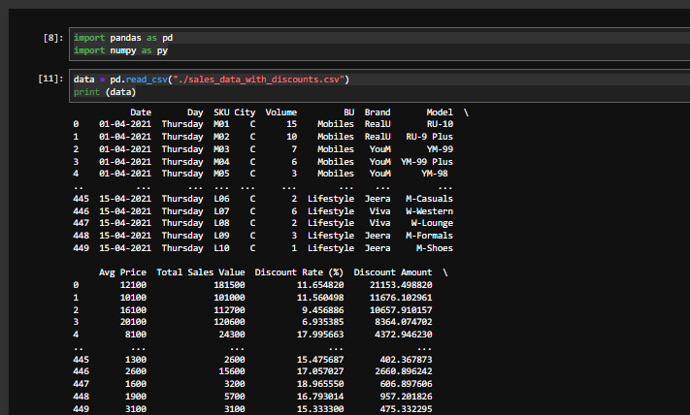
  - Identify numerical columns in the dataset.
    - df = pd.DataFrame(data) 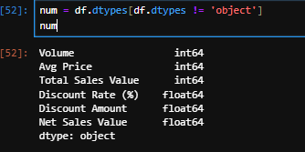
  - Calculate the mean, median, mode, and standard deviation for these columns.
    - mean = df.mean(numeric_only=True) -> to get mean
    - mode = df.mode() -> mode
    - median = df.median(numeric_only=True) -> median
    - df.std(numeric_only=True) -> standard deviation
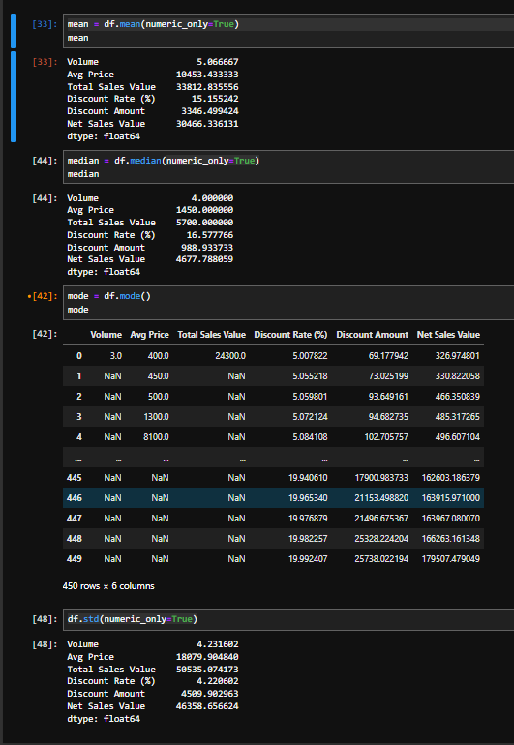
  - Provide a brief interpretation of these statistics.
    - df.describe()
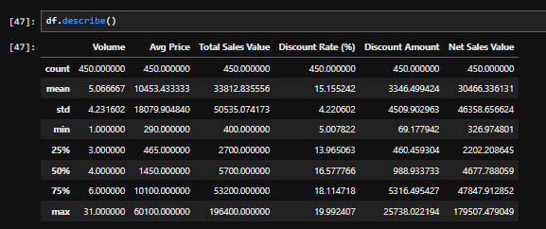

Data Visualization
- Objective: To visualize the distribution and relationship of numerical and categorical variables in the dataset.
- Histograms:
  - Plot histograms for each numerical column.
    - import matplotlib.pyplot as plt
import seaborn as sns

sns.histplot(df["Volume"], bins=20,kde=True)
plt.show()

sns.histplot(df["Avg Price"], bins=20,kde=True)
plt.show()

sns.histplot(df["Total Sales Value"], bins=20,kde=True)
plt.show()

sns.histplot(df["Discount Rate (%)"], bins=20,kde=True)
plt.show()

sns.histplot(df["Discount Amount"], bins=20,kde=True)
plt.show()

sns.histplot(df["Net Sales Value"], bins=20,kde=True)
plt.show()
  - Analyze the distribution (e.g., skewness, presence of outliers) and provide inferences.
    - skew_vol = df["Volume"].skew()
    - print("Skewness of Volume:", skew_vol)
- Boxplots:
  - Create boxplots for numerical variables to identify outliers and the interquartile range
    - plt.figure(figsize=(4,4))

    - plt.boxplot(df["Volume"], tick_labels=['Count'], patch_artist=True)
    - plt.title('Volume')
    - plt.ylabel('Count')
    - plt.show()

    - plt.boxplot(df["Avg Price"], tick_labels=['Count'], patch_artist=True)
    - plt.title('Volume')
    - plt.ylabel('Count')
    - plt.show()

    - plt.boxplot(df["Total Sales Value"], tick_labels=['Count'], patch_artist=True)
    - plt.title('Volume')
    - plt.ylabel('Count')
    - plt.show()

    - plt.boxplot(df["Discount Rate (%)"], tick_labels=['Count'], patch_artist=True)
    - plt.title('Volume')
    - plt.ylabel('Count')
    - plt.show()

    - plt.boxplot(df["Discount Amount"], tick_labels=['Count'], patch_artist=True)
    - plt.title('Volume')
    - plt.ylabel('Count')
    - plt.show()

    - plt.boxplot(df["Net Sales Value"], tick_labels=['Count'], patch_artist=True)
    - plt.title('Volume')
    - plt.ylabel('Count')
    - plt.show()

  - Discuss any findings, such as extreme values or unusual distributions.
- Bar Chart Analysis for Categorical Column:
  - Identify categorical columns in the dataset.
- cat_cols = df.select_dtypes(include=['object', 'category']).columns
print("Categorical columns:", cat_cols)
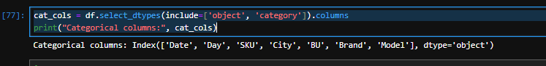
  - Create bar charts to visualize the frequency or count of each category.
  - Analyze the distribution of categories and provide insights.
  - 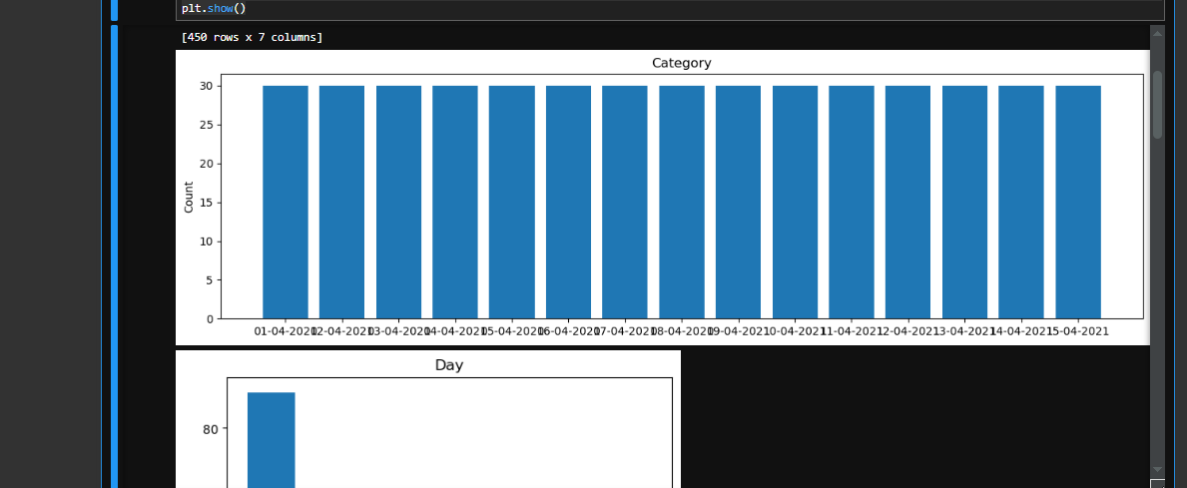

Standardization of Numerical Variables
- Objective: To scale numerical variables for uniformity, improving the dataset’s suitability for analytical models.
- Steps:
  - Explain the concept of standardization (z-score normalization).
    - Update numerical value to common scale so that no single value causes difference in scale while taking analysis. Standardization transforms numerical value so that they have mean 0 and std deviation 1
  - Standardize the numerical columns using the formula: z=x-mu/sigma
  - Show before and after comparisons of the data distributions.

Conversion of Categorical Data into Dummy Variables
- Objective: To transform categorical variables into a format that can be provided to ML algorithms.
- Steps:
  - Discuss the need for converting categorical data into dummy variables (one-hot encoding).
    - To transform non numerical data to numerical data that can be used. It converts non numerical value like BU, City to numerical value i.e binary value 0 or 1
  - Apply one-hot encoding to the categorical columns, creating binary (0 or 1) columns for each category.
  - Display a portion of the transformed dataset.
  - 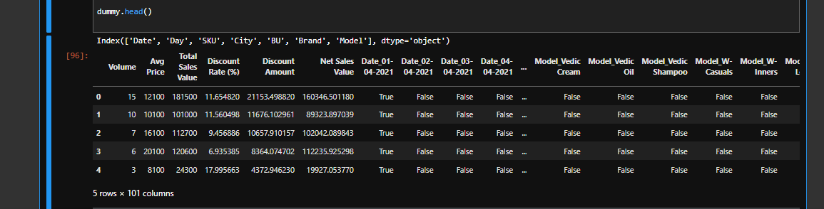

Conclusion
- Summarize the key findings from the descriptive analytics and data visualizations.
  - descriptive analytic contains dataset of both numerical and non numerical data’s, which requires pre-processing steps to generate a good / efficient set of data
  - Visualization like graphs like bar, plot, histogram helps you to identify the patterns, dominant areas and data mismatch if any
- Reflect on the importance of data preprocessing steps like standardization and one-hot encoding in data analysis and machine learning
  - Standardization updates the data scale such that the data difference while taking analysis is reduced while one hot encoding converts the non-numerical values which are not recognized by the machine to a machine recognizable format such as 0 or 1 making it easier to analysis the data

